**3. Resume Creation Using HTML and CSS**

|  |  |
| --- | --- |
| NAME | VAISHALI |
| SAP ID | 500093160 |
| COURSE | BBA(Analytics and Big data) |
| SUBJECT | WEB Analytics |

**INPUT:**

<html lang="en">

<head>

<meta charset="UTF-8">

<meta http-equiv="X-UA-Compatible" content="IE=edge">

<meta name="viewport"

content="width=device-width, initial-scale=1.0">

<link rel="stylesheet" href="resume3.css">

</head>

<body>

<div class="full">

<div class="left">

<div class="image">

<img src= "C:\Users\Admin\Downloads/photo.jpeg"

alt="gfg-logo"

style="width:100px;height:100px;">

</div>

<div class="Contact">

<h2>Contact</h2>

<p><b>Email id:</b>vaishalikshetriya02@gmail.com</p>

<p><b>Linkdin id:</b><a href="https://www.linkedin.com/in/vaishali-7419a123b">Vaishali</a></p>

<p><b>Mobile no:</b>8193069989</p>

<p><b>GITHUB:</b><a href="https://github.com/Vkshetriya/Vaishali">Vaishali</a></p>

</div>

<div class="Skill Set">

<h2>Soft Skills</h2>

<ul>

<li><b>Communication</b></li>

<li><b>Adaptibility</b></li>

<li><b>Empathy</b></li>

<li><b>Multitasking</b></li>

</ul>

<h2>Technical Skills</h2>

<ul>

<li><b>Web tool: HTML</b></li>

<li><b>Microsoft Office: MS-Word, MS-Excel, MS-Power Point</b></li>

<li><b>Database: SQL</b></li>

<li><b>Tableau</b></li>

</ul>

</div>

<div class="Language">

<h2><b>Language</h2>

<ul>

<li>English</li>

<li>Hindi</li>

</ul>

</div>

</div>

<div class="right">

<div class="name">

<h1>Vaishali</h1>

</div>

<div class="Agile,Diplomatic,Detail-oriented">

<p>Agile,Diplomatic,Detail-oriented</p>

</div>

<div class="Career Objective">

<h2>Career Objective</h2>

<p>Tenacious individual as a business analyst with great analytical, communication and research skills and demonstrated ability to learn quickly and work well as a part of a team or independently as needed.

</p>

</div>

<div class="Academic Background">

<h2>Academic Background</h2>

<table border = "1" cellpadding = "2">

<tr>

<th>University/college</th>

<th>Degree</th>

<th>Year(s)</th>

<th>percentage</th>

</tr>

<tr>

<td>University of Petroleum and Energy Studies</td>

<td>BBA(Analytics and Big Data)</td>

<td>2021-2024</td>

<td>-</td>

</tr>

<tr>

<td>Kendriya Vidyalaya Haldwani</td>

<td>XII</td>

<td>2020-2021</td>

<td>81%</td>

</tr>

<td>Kendriya Vidyalaya Haldwani</td>

<td>X</td>

<td>2018-2019</td>

<td>70%</td>

</tr>

</table>

<div class="Extra Curricular Activities/Achievements">

<h2>Extra Curricular Activities/Achievements</h2>

<ul>

<li>Social Intern with Let's give hope foundation in 2022</li>

<li>National player in Basketball</li>

<li>Sports Captain in School</li>

<li>Got 1st Prize in Dance</li>

<li>SPR of the Class</li>

</ul>

</div>

</div>

</div>

</div>

</body>

</html>

**OUTPUT:**

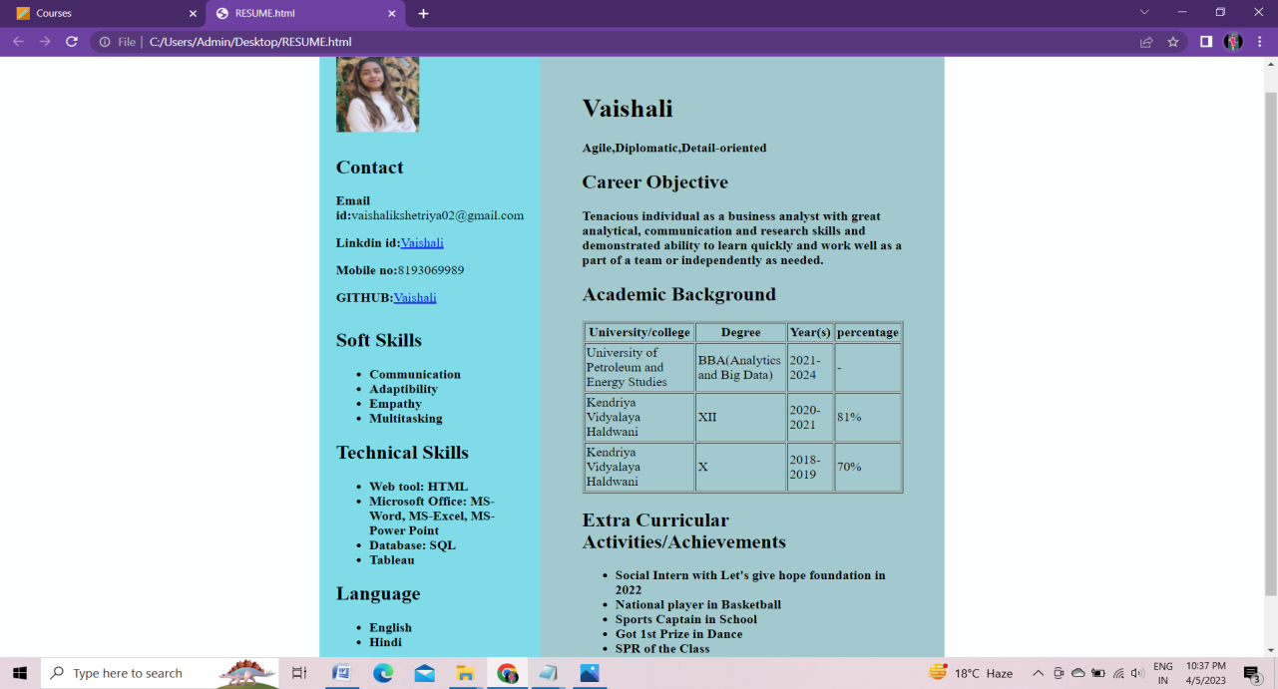

**CSS:**

{

margin: 0;

padding: 0;

box-sizing: border-box;

}

body {

background-color: rgb(253, 254, 255);

display: flex;

justify-content: center;

align-items: center;

}

.full {

width: 50%;

max-width: 1000px;

min-height: 100px;

background-color: rgb(245, 239, 231);

margin: 0px;

display: grid;

grid-template-columns: 2fr 4fr;

}

.left {

position: initial;

background-color: rgb(126, 219, 231);

padding: 20px;

}

.right {

position: initial;

background-color: rgb(162, 202, 206);

padding: 50px;

}

.image, .Contact, .Soft Skills, .Technical Skills, .Language, .Career Objective, .Academic Background, .Extra Curricular /Activities {

margin-bottom: 30px;

}

.h2 {

background-color: rgb(4, 96, 150);

}